**The Islamia University of Bahawalpur**

**Department of Software Engineering**

**Faculty of Computing**



**software design description (SDD)**

**for**

**<Facial Emotion Detection>**

##### Version 1.0

**By**

**Suman Mukhtar**

**SP20M2BE032**

**M1**

**Session Spring 2020 – 2024**

**Supervisor**

**Mrs. Sunnia Ikram**

**Bachelor of Science in Software Engineering**

**Table of Contents**

**1. INTRODUCTION**

1.1 Purpose

1.2 Scope

1.3 Overview

1.4 Reference Material

1.5 Definitions and Acronyms

**2. SYSTEM OVERVIEW**

General description of the functionality, context and design of system/software.

**3. SYSTEM ARCHITECTURE**

3.1 Architectural Design

This is a high level overview of how responsibilities of the system were partitioned and then assigned to subsystems. Provide a diagram showing the major subsystems and data repositories and their interconnections. Describe the diagram if required.

3.2 Decomposition Description

Functional description or an object oriented description. For a functional description, put top-level data flow diagram (Context Diagram) and structural decomposition diagrams.

**Class Diagram**

**Activity Diagram**

**Sequence Diagram**

For an OO description, put subsystem model, object diagrams, generalization hierarchy diagram(s) (if any), aggregation hierarchy diagram(s) (if any), interface specifications, and sequence diagrams here.

3.3 Design Rationale

Critical issues and trade/offs

**4. DATA DESIGN**

4.1 Data Description

Describe how the major data or system entities are stored, processed and organized. List any databases or data storage items.

4.2 Data Dictionary

Alphabetically list the system entities or major data along with their types and descriptions.

4.3 Data Model

ERD

Database

Tables

**5. COMPONENT DESIGN**

Summary of your algorithm for each function for functional description in procedural description language (PDL) or pseudocode. Summarize each object member function for all the objects for OO description.

**6. REQUIREMENTS MATRIX**

**1. INTRODUCTION**

**1.1 Purpose**

The purpose of this document is to provide a detailed description of the design of the Facial Emotion Detection system using the DeepFace library.

**1.2 Scope**

The system will analyze facial images and detect the primary emotion displayed in each image. The system will be developed using the DeepFace library, which provides advanced facial analysis algorithms.

**1.3 Overview**

The system will consist of a graphical user interface (GUI) that allows users to upload images and view the results of the emotion analysis. The system will use the DeepFace library to perform facial analysis and detect the primary emotion displayed in each image.

**1.4 Reference Material**

The following references were used in the development of this document:

DeepFace library documentation

Python documentation

**1.5 Definitions and Acronyms**

GUI: Graphical User Interface

DeepFace: A Python library for facial analysis

**2. SYSTEM OVERVIEW**

The Facial Emotion Detection system will analyze facial images and detect the primary emotion displayed in each image. The system will consist of a GUI that allows users to upload images and view the results of the emotion analysis. The system will use the DeepFace library to perform facial analysis.

**3. SYSTEM ARCHITECTURE**

3.1 Architectural Design

The system will be divided into two major subsystems: the GUI and the emotion detection subsystem. The GUI will be responsible for accepting user input and displaying output to the user. The emotion detection subsystem will use the DeepFace library to perform facial analysis and detect the primary emotion displayed in each image.

3.2 Decomposition Description

The GUI subsystem will consist of the following components:

* Upload Image button
* Display Image area
* Emotion Prediction area

The emotion detection subsystem will consist of the following components:

* Image Input
* Facial Analysis
* Emotion Detection
* Emotion Output

3.3 Design Rationale

The DeepFace library was chosen for its advanced facial analysis algorithms and its ease of use in Python.

**4. DATA DESIGN**

4.1 Data Description

The system will not store any data for further use or processing.

4.2 Data Dictionary

Facial Emotion Detection :

The process of automatically detecting and recognizing emotions from human facial expressions.

DeepFace:

A deep learning facial recognition system developed by Facebook that can be used for facial emotion detection.

Preprocessing:

The process of preparing input data for a machine learning algorithm, such as normalizing or scaling the data.

CNN:

Convolutional neural network, type of deep learning algorithm which is commonly used for image and video recognition tasks.

Training data:

A set of output/input couples used to train one or more machine learning models. In this case, images of faces labeled with the corresponding emotion they represent.

Test data:

A set of input/output pairs used to evaluate the performance of a machine learning model. In this case, images of faces not seen during training labeled with the corresponding emotion they represent.

Accuracy:

A measure of how well a machine learning model is able to correctly predict the output given an input.

Precision:

A measure of how often a machine learning model correctly predicts a positive class (e.g. a specific emotion), given that it has made a positive prediction.

Recall:

A measure of how often a machine learning model correctly predicts a positive class (e.g. a specific emotion), given that the actual class is positive.

F1 score:

A measure of a machine learning model's accuracy that takes both precision and recall into account. It is the harmonic instrument of precision and rotation.

User interface:

The part of the system that the user interacts with, which allows them to input an image and receive the predicted emotion.

Web application:

A software application that runs on a web server and is accessed via a web browser.

API:

Application Programming Interface, framework and software development tools. In this case, the API would allow other software applications to communicate with the facial emotion detection system.

4.3 Data Model

N/A

**COMPONENT DESIGN**

The emotion detection subsystem will be implemented as follows:

**DATA FLOW DIAGRAM**

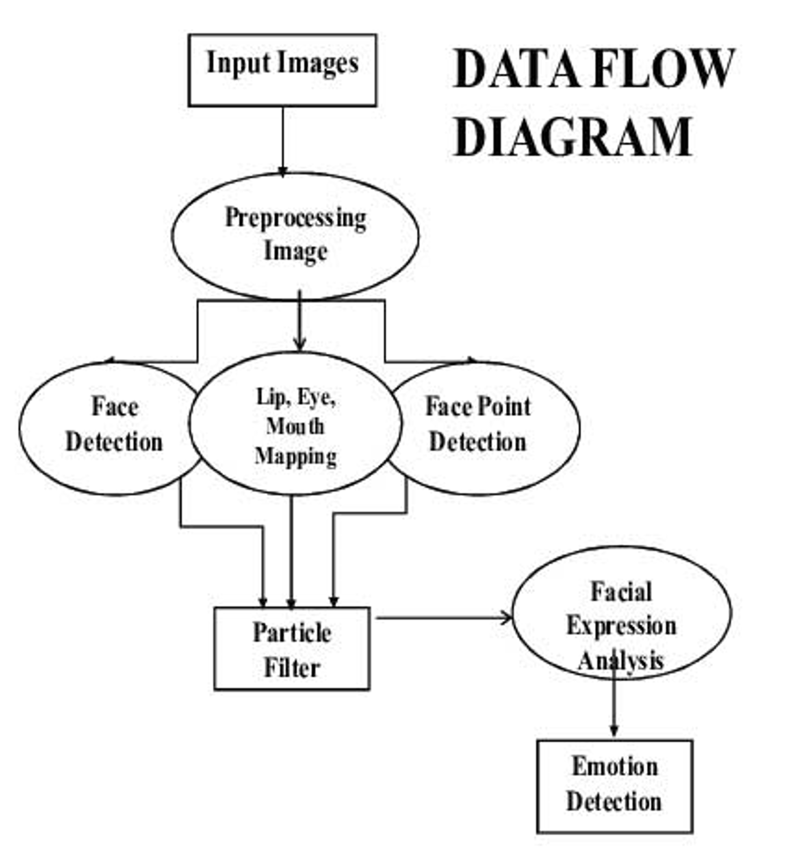

**UML DIAGRAM**

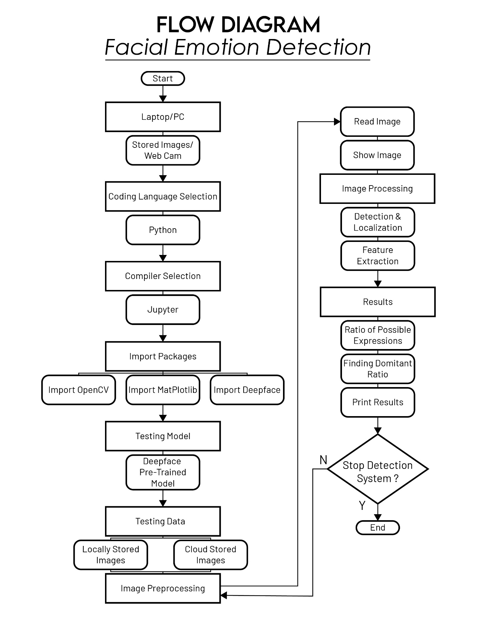

**ENTITY RELATIONSHIP DIAGRAM**

Not Applicable

**REQUIREMENTS MATRIX**

The following table shows the requirements for the Facial Emotion Detection system and how they are addressed in the design:

| **Requirement** | **Design** |
| --- | --- |
| The system must allow users to upload images | The GUI subsystem includes an Upload Image button |
| The system must display the uploaded image | The GUI subsystem includes a Display Image area |
| The system must display the primary emotion displayed in the image | The GUI subsystem includes an Emotion Prediction area, and the emotion detection subsystem performs facial analysis to detect the primary emotion |
| The system must be easy to use | The GUI is designed to be user-friendly |
| The system must be accurate | The DeepFace library is used for its advanced facial analysis algorithms |
| The system must be fast | The DeepFace library is optimized for performance |

This concludes the draft of the Software Design Document (SDD) for your Facial Emotion Detection system using the DeepFace library. Please note that this is just a template and should be modified based on your specific requirements and needs.